**Maximal Rectangle:-**

Given a rows x cols binary matrix filled with 0's and 1's, find the largest rectangle containing only 1's and return *its area*.

**Example 1:**

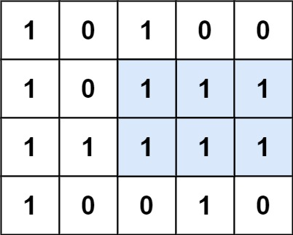

**Input:** matrix = [["1","0","1","0","0"],["1","0","1","1","1"],["1","1","1","1","1"],["1","0","0","1","0"]]

**Output:** 6

**Explanation:** The maximal rectangle is shown in the above picture.

**Example 2:**

**Input:** matrix = []

**Output:** 0

**Example 3:**

**Input:** matrix = [["0"]]

**Output:** 0

**Example 4:**

**Input:** matrix = [["1"]]

**Output:** 1

**Example 5:**

**Input:** matrix = [["0","0"]]

**Output:** 0

**Constraints:**

* rows == matrix.length
* cols == matrix.length
* 0 <= row, cols <= 200
* matrix[i][j] is '0' or '1'.